A000-ME-Persia-Darius I-Seal-Cylinder-Hunter-Lion-Chariot-Agate-522-486 BCE

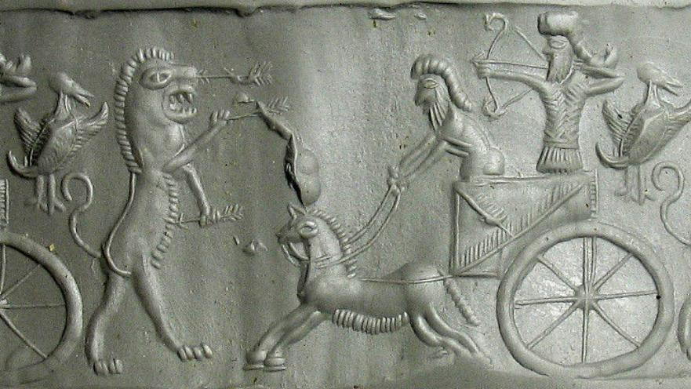

Fig. 1. Impression of Persia-Darius I-Seal-Cylinder-Hunter-Lion-Chariot-Agate-522-486 BCE

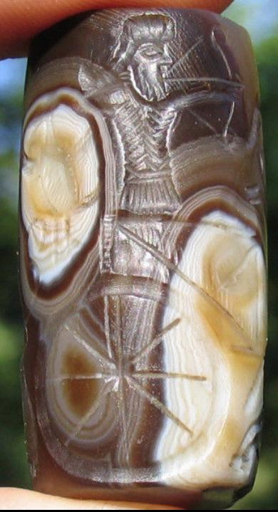

Fig. 2. Persia-Darius I-Seal-Cylinder-Hunter-Lion-Chariot-Agate-522-486 BC

Formal Label: Persia-Darius I-Seal-Cylinder-Hunter-Lion-Chariot-Agate-522-486 BCE

Accession Number: A000

**Display Description:**

Darius I, king of ancient Persia, (reign 522 to 486 BCE). After killing king Gaumâta and fighting a civil war, which is described in the Behistun inscription, he came to the throne and re-founded the Achaemenid Empire. Darius fought several foreign wars in India and Thrace which gained the largest extent of the Persian Empire.

One of Darius' seals, an agate cylinder of about 3.7 centimeters high, engraved with a picture of the king hunting from his chariot, was probably found in a tomb near Thebes (Egypt) and is now in the British Museum.

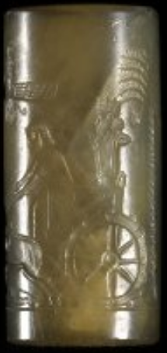 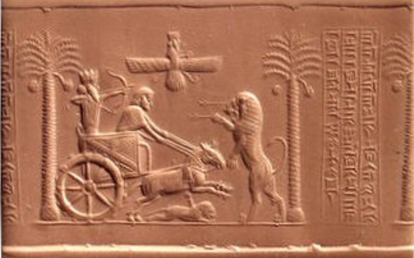

Fig. 3. The seal of Persian King Darius the Great, 486 BCE, Courtesy of the British Museum.

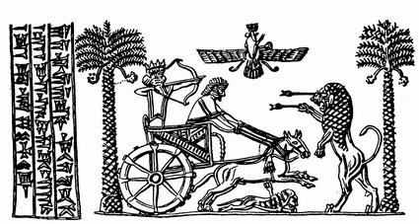

Fig. 4. Drawing of the seal of Persian King Darius the Great, 486 BCE. From http://www.livius.org/site/assets/files/1937/thumbnail_darius_seal2.jpg

The third row of the Persian cuneiform text. The last sign is an abbreviation for *xšâyathiya*, "king."



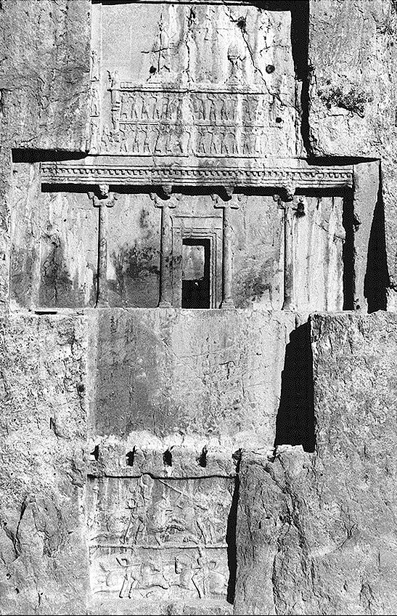 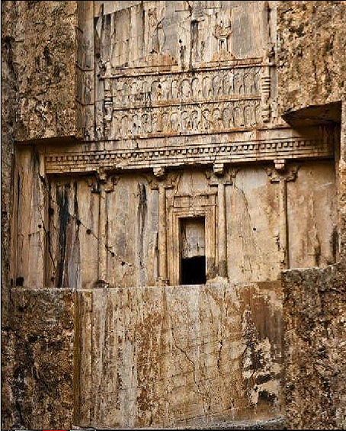

Fig 3. Naqš-e Rostam, tomb of Darius I (Tomb I). Courtesy of the Deutsches Archäologisches Institut.

Fig. 4. Naqš-e Rostam, tomb of Darius I (Tomb I). <https://i.pinimg.com/564x/c1/e0/e8/c1e0e86fb31223687cb1f523f382d228.jpg>

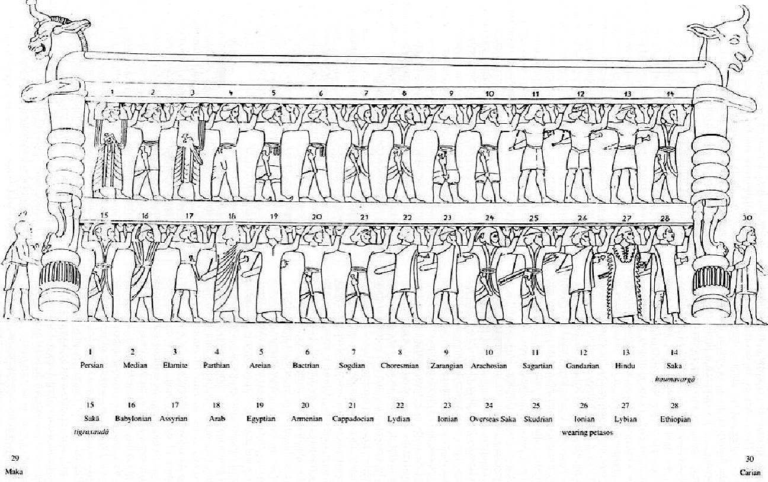

Fig. 5. The throne bearers or subject satrapies showing their diverse clothing illustrated high on the tomb of Darius I of Huseyn Kuh at Naqš-e Rustam (ancient Nupistaš) 5 km NW of Persepolis.

Date or Time Horizon: 486 BCE

Geographical Area: Huseyn Kuh at Naqš-e Rustam (ancient Nupistaš) 5 km NW of Persepolis

**Map:**

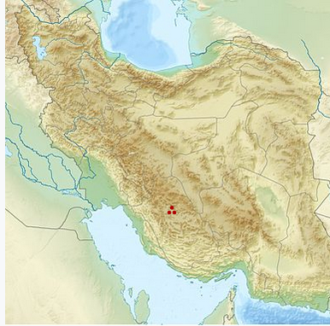

Fig. 6. Map of Huseyn Kuh at Naqš-e Rustam (ancient Nupistaš) 5 km NW of Persepolis https://upload.wikimedia.org/wikipedia/commons/thumb/3/31/Iran_relief_location_map.jpg/428px-Iran_relief_location_map.jpg

**GPS**: [29°59′20″N 52°52′29″E](https://tools.wmflabs.org/geohack/geohack.php?pagename=Naqsh-e_Rustam&params=29_59_20_N_52_52_29_E_type:landmark)

Cultural Affiliation: Darius I

Medium: Agate

Dimensions: H 44 mm

Weight:

Provenance: Old English Collection

Discussion:

Darius built two large palace cities: Persepolis and Susa, which replaced Pasargadae as capital of the Persian Empire. There may have been other palaces in cities like Babylon and Ecbatana, but these have not been located. The *satrapies* or "protectors of the realm" were vassal kings who also built their own palace cities, like Sardes, the capital of ancient Lydia, the kingdom founded by king Gyges (r. c.680-c.644) and mentioned by historian-researcher Herodotus of Halicarnassus (ca 480-ca429 BCE). Sardes was multi-religious and had the temple of Cybele/Artemis as an important monument. Other native deities were Sabazius and Argistis. Sardes was connected with the Persian heartland by the Royal Road that connected the capital of Lydia, Sardes, with the capitals of the Achaemenid Empire, Susa and Persepolis.

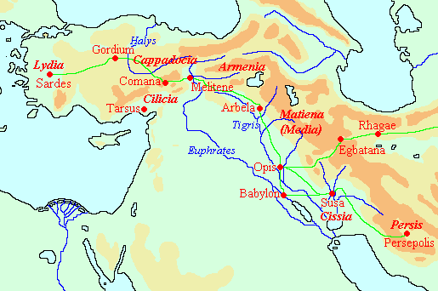

Fig. 7. Map: of the Royal Road connecting the satrapies of Darius I.

Created by Jona Lendering, Attribution-NonCommercial-ShareAlike 4.0 International, http://www.livius.org/site/assets/files/8131/royal_road_map2.gif

|  |  |
| --- | --- |
|  |  |

Darius' best-known building project is Persepolis, or, to use its Persian name, Pârsa. It was to be the splendid seat of the government of the Achaemenid Empire, where the king received guests at the New Year festival (Now Ruz). Starting c.515, Darius' men leveled the ground and created a [terrace](http://www.livius.org/pen-pg/persepolis/persepolis_terrace.html) of 450x300 meters, on which stood the Treasury and the Audience hall (Apadana). In the Treasury were stored the booty of the conquered tribes and the annual tribute, now fixed, from the king's subjects. The *Apadana* could accommodate hundreds of people at the same time. The seventy-two columns which supported the roof were twenty-five m high. The building inscription reads:

“Darius the great king, king of kings, king of countries, son of Hystaspes, an Achaemenian, built this palace.”

Darius' palace, Persepolis, Pârsa, the seat of the government of the Achaemenid Empire, where the king received guests at the New Year festival (Now Ruz).

Starting c.515, Darius' men leveled the ground and created a terrace of 450x300 m, on which stood the Treasury and the Audience hall (Apadana). These buildings were finished in 490. At the end of Darius' reign, a small palace was added. The remarkable cavetto elements that crown the doors are an Egyptian influence. It was called Taçara, 'winter palace', but Darius probably did not live to see the building finished

References: